12V Upgrade Project
Catalina 320, Hull #62
Starting Battery
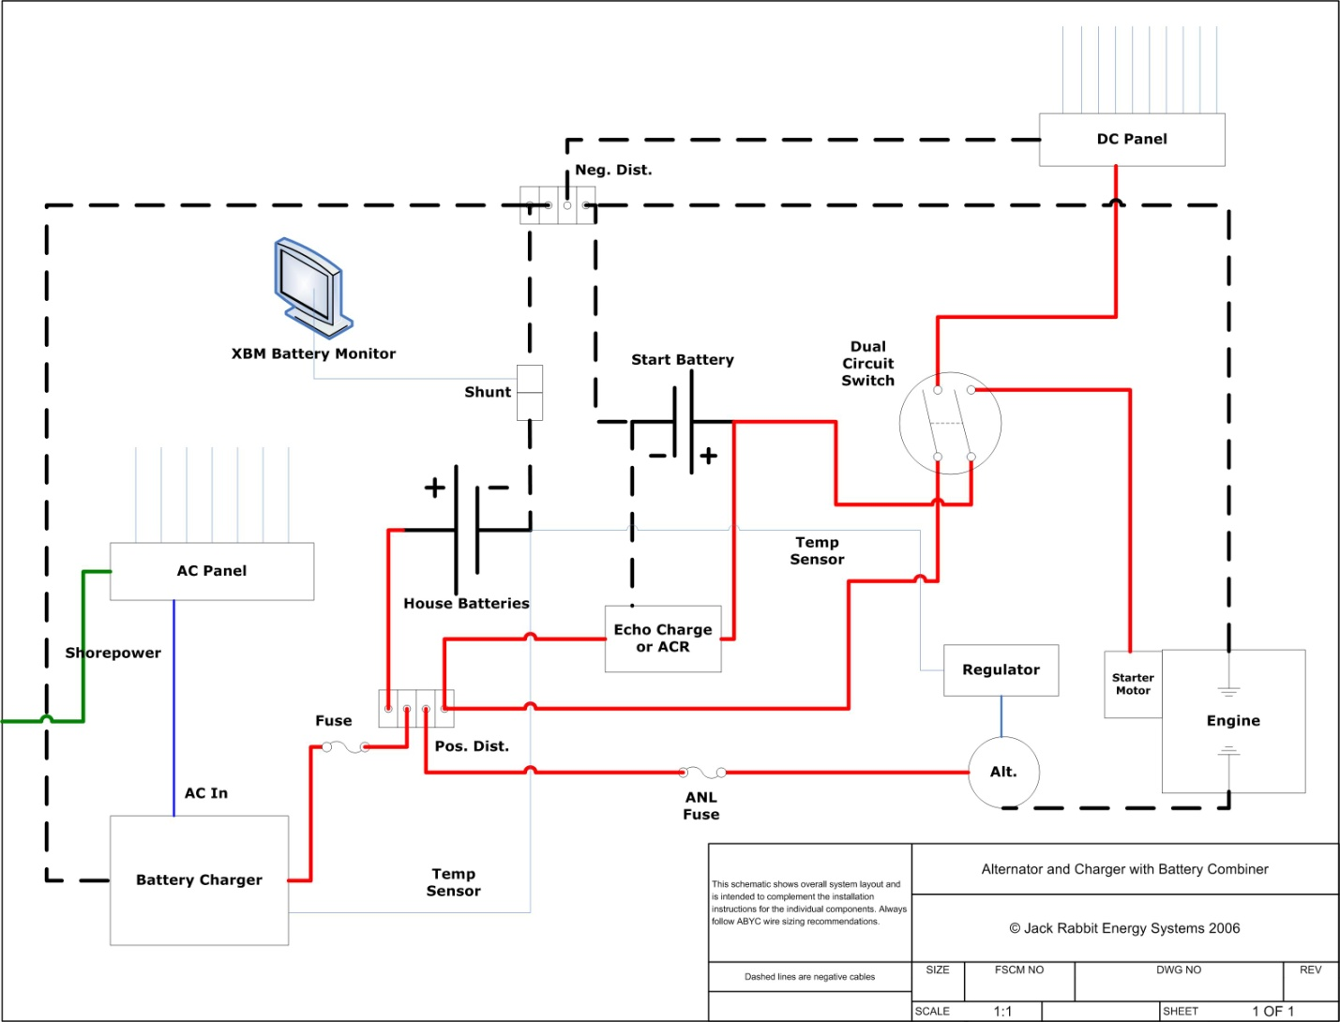
Here is the wire diagram from Jack Rabbit Energy (now defunct,) that I followed for my project. It is essentially the same as an approach described on the C320 web site. Note the “Dual Circuit Switch” and follow the positive leads to see how the starting circuit and the house circuit are completely separate.

There are different approaches to the shelf for the starting battery and there are pictures on the C320 web site. I chose to make mine of plywood with two vertical supports. I used cardboard to make a model to conform to the hull. The verticals are reinforced with a block of wood, and the whole thing is “painted” with unfilled epoxy to seal and make watertight. (I love epoxy. It’s so useful.)
You’ll see two nuts imbedded in the edges of the shelf. They are to accept the bolts of the hold-down. There are also different approaches to containing the battery. Some use a fully enclosing battery case, some tie-down straps, etc. As the entire starboard side under the settee is a fairly isolated pit, I decided I would just install it open on the shelf. Most auto batteries have a recess front and rear to accept a small stepped bracket as a hold-down. I found the bracket at an auto store. I figured this would make it easy to remove and install the battery.

Here is the underside of the shelf:
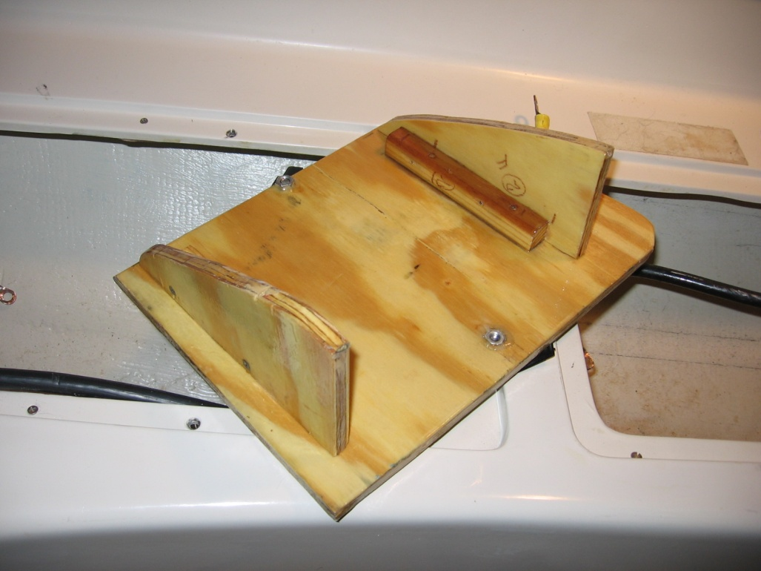
Here is the battery shelf in-place; and, you can see the hold-down brackets in-place:
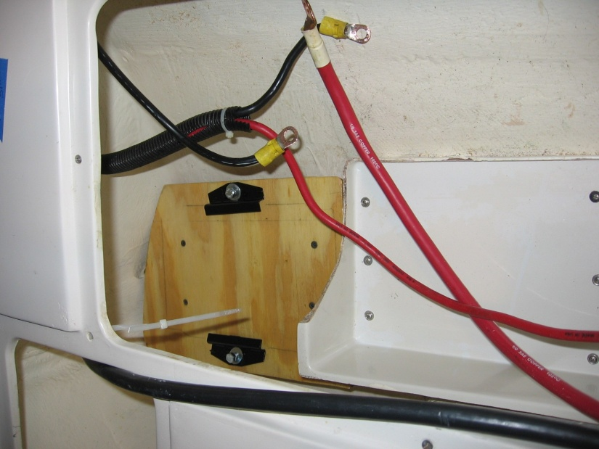
Once I was satisfied with the positioning I made pencil lines along the top and verticals where they touch the hull then ran beads of 5200 along the pencil lines, and placed the shelf on the 5200. I did put a weight on the shelf to keep it in-place.
Paralleling the House Batteries
To parallel the house batteries, you need only add a positive cable between the positive posts of the two batteries. Then, add a negative cable from the house bank to the starting bank. One of the positive cables that was on one of the 4-Ds will stay there. The positive cable that was on the other 4-D needs to go to the positive on the starting bank (you will need a new cable for this because it probably won’t be long enough.) Be sure all cables are the same size as the ones leading out of the battery compartment. Before connecting it all up, be sure to clean all the connections well as any corrosion will increase voltage drop and effect engine starting and battery charging. Also, use a meter to determine which is the house positive cable and which is the starting positive cable. This will be important at the switch.
Dual Circuit Switch
As for the switch, you can use your original switch and the instructions for wiring that for the above changes are on the C320 web site. The Blue Sea e-series (5511e in red or black,) is about $45, on-line, makes a set-it and forget-it process. Otherwise, you still have to select the start bank to start the engine, switch to Both while running, and change the switch to the house bank when the engine is off. For me, that’s a real pain.
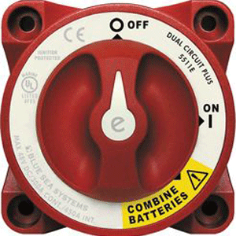
Here is the back of the switch once installed:
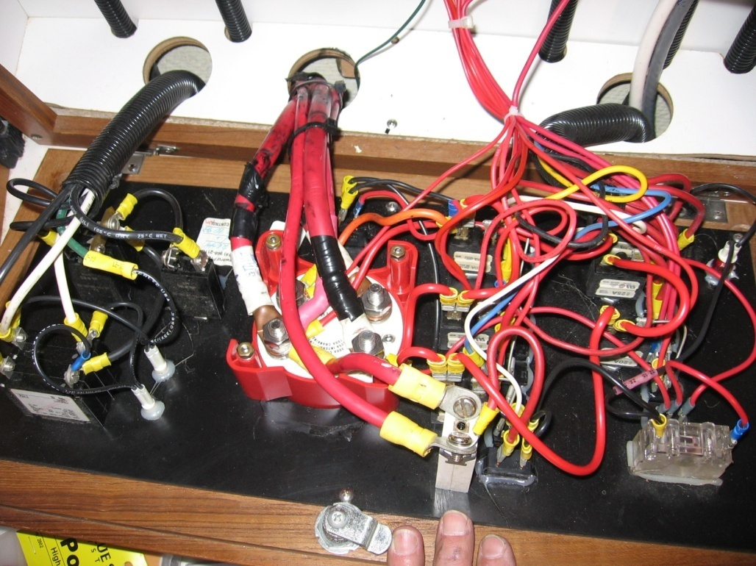
The above picture shows how the older 320 were wired. I think the newer ones are better done. There are four posts on this switch: two for house and two for starting. Each pair is a separate circuit and both circuits are switched at the same time. Note that only the positive cables are connected. The negative is a single run with both banks, the engine, and the negative terminal strip for the house all connected on the black cable. This was accomplished by connecting the negative posts on the house and starting batteries described above.
However, and this is a big deal, to separate the alternator charging current from the house bank, it will be necessary to install a new positive cable from the alternator to the house bank. The existing cable from the alternator output to the starter must be removed. It is best to take this cable all the way back to the house bus or battery terminal. On the older hulls with a water tank under the port settee, it is easier to bring this cable up behind the switch and put on the same post as the cable from the house bank.
Once you have the necessary cables where you need them, you must identify each positive cable on the existing switch:
- From the starting bank
- To the starter
- From the house bank
- To the house distribution
Using the instructions for the new switch, connect 1. and 2. to one pole of the switch and connect 3. and 4. to the other pole. That should do it. If the alternator charge cable comes to the switch, place it on the same post as #3. Test the switch positions at the battery side with a meter making sure each cable is what you think it should be with the switch in each of the three positions.
Here is a picture of the completed set-up:
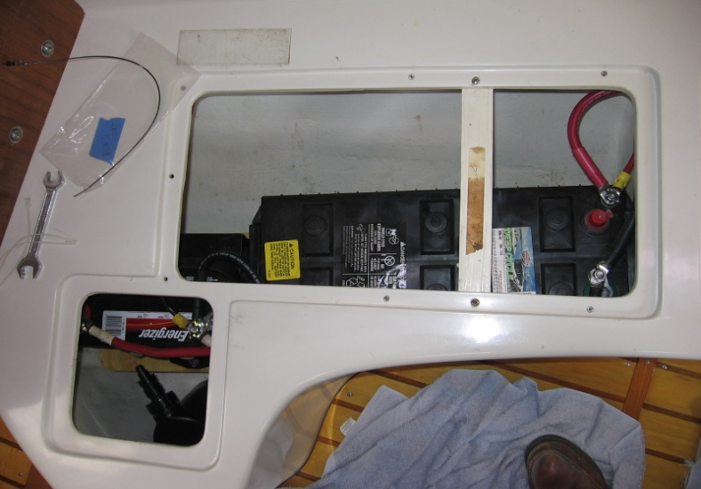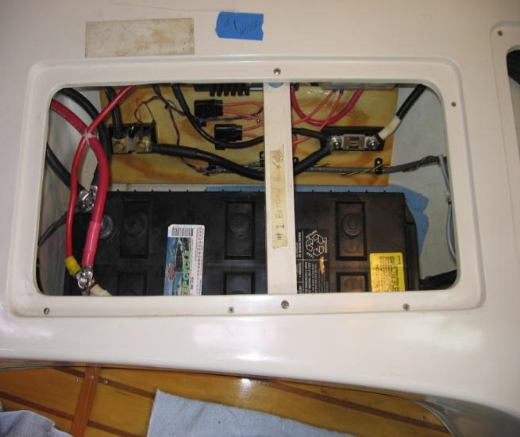

Other Components
Ok, so what’s with all the wires and stuff outboard of the aft battery? My project also included installing:
- high output alternator
- external regulator
- battery monitor
- charging relay
Since the most wires you should have on any post is three, I used buss bars and a separate mounting board to contain all the components. Thus, the number of cables directly attached to the batteries is minimized. I don’t have more than two on any battery post. The disadvantage is that there are more connections and more potential for voltage loss. Add that to your maintenance list. Also, if you don’t already have fuses in the battery cables, the ABYC recommends that you have them within a certain number of inches from the positive battery terminals. My technical advisor recommended only a single 150A fuse in the negative cable near to the battery. As all the power is common to the negative cable, I went with that approach.
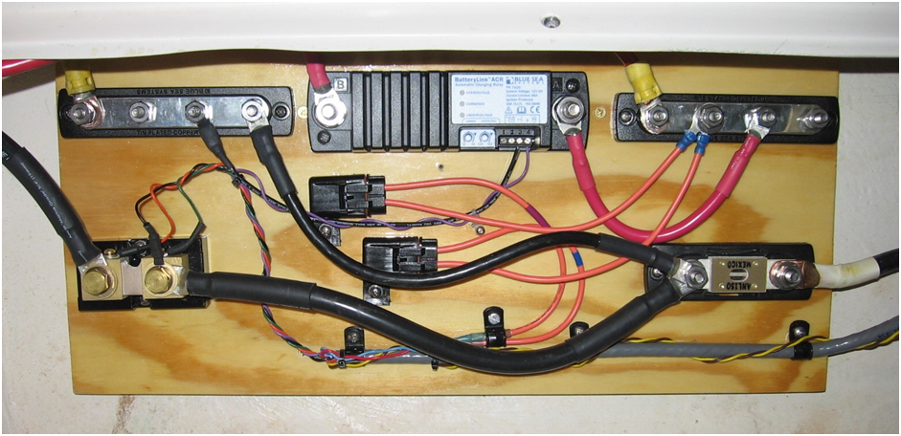Here is an annotated picture of the component board:
To shore charger
Negative Bus
Charging Relay
To Start Battery
Positive Bus

Fuses for batt. monitor
Shunt for batt. monitor
Power and data for batt. monitor
Fuse in neg. cable
To house Bank

Alternator and Regulator Installation
This is left for another time.

--- End ---

